THE BEST AND WORST OF MAPA 2000
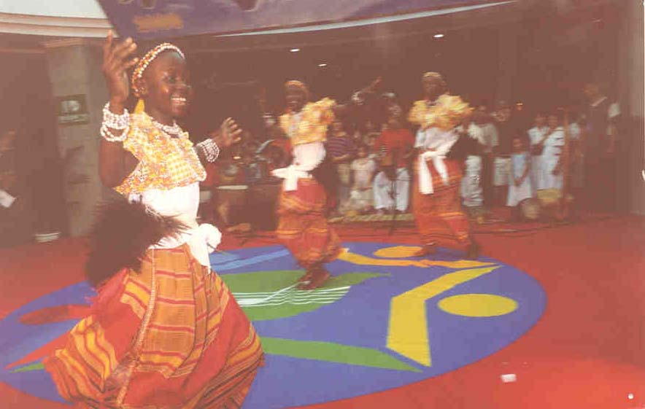

...... As for their dance, I spent literally the whole holiday practising it but I am yet to consult Serunjogi)... if all goes well, I guess I will not have any trouble in wooing my brand of cultures and other dances.

Mutesa house emerged second. I really liked their traditional folk song (from Ankole) and their Ekitanguriro dance.

Finally, Africa emerged champions of MAPA – 2000. One of the perfects (Kawalya Douglas) was so overwhelmed by the broke into his own version of “Amagunju Dance”.

When contacted for comment; the house prefect (Lillian Mirembe) was so excited that she could hardly talk; she only managed to say, “I don’t know.”
The Head-girl (Nakamya Flora) said “Eh, it is God who enabled us .......” she followed this with a long sermon about Africa and God – unfortunately I couldn’t match the speed of her sermon Note; Nakamya and God are inseparable.

